NAME: RAMYA RAMESH

USN: 1BM19CS227

**PROGRAM 3 = SUPPLIER DATABASE**

create database supplier;

use supplier;

create table SUPPLIERS(sid int, sname varchar(20), city varchar(20), primary key(sid));

desc SUPPLIERS;

create table PARTS(pid int, pname varchar(20), color varchar(10), primary key(pid));

desc PARTS;

create table CATALOG(sid int, pid int, cost real, primary key(sid,pid), foreign key(sid) references SUPPLIERS(sid), foreign key (pid) references PARTS(pid));

desc CATALOG;

insert into SUPPLIERS values(10001,'Acme Widget','Bangalore');

insert into SUPPLIERS values(10002,'Johns','Kolkata');

insert into SUPPLIERS values(10003,'Vimal','Mumbai');

insert into SUPPLIERS values(10004,'Reliance','Delhi');

commit;

select * from SUPPLIERS;

insert into PARTS values(20001,'Book','Red');

insert into PARTS values(20002,'Pen','Red');

insert into PARTS values(20003,'Pencil','Green');

insert into PARTS values(20004,'Mobile','Green');

insert into PARTS values(20005,'Charger','Black');

commit;

select * from PARTS;

insert into CATALOG values(10001,20001,10);

insert into CATALOG values(10001,20002,10);

insert into CATALOG values(10001,20003,30);

insert into CATALOG values(10001,20004,10);

insert into CATALOG values(10001,20005,10);

insert into CATALOG values(10002,20001,10);

insert into CATALOG values(10002,20002,20);

insert into CATALOG values(10003,20003,30);

insert into CATALOG values(10004,20003,40);

commit;

select * from CATALOG;

TABLES:

1. SUPPLIERS:

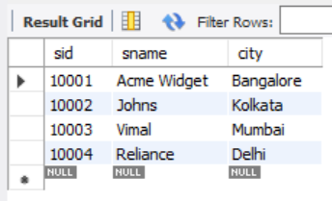

1. PARTS:

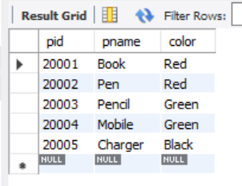

1. CATALOG:

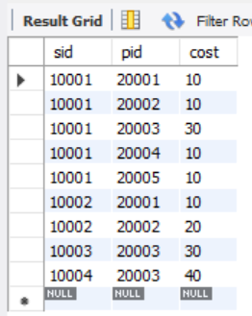

QUERIES:

1. Find the pnames of parts for which there is some supplier.

select distinct P.pname from PARTS P, CATALOG C where P.pid = C.pid;

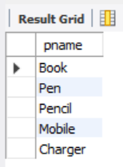

1. Find the snames of suppliers who supply every part.

select S.sname from SUPPLIERS S where not exists (select P.pid from PARTS P where not exists (select C.sid from CATALOG C where C.sid = S.sid and C.pid = P.pid));

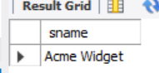

1. Find the snames of suppliers who supply every red part.

select S.sname from SUPPLIERS S where not exists (select P.pid from PARTS P where P.color = 'Red' and (not exists (select C.sid from CATALOG C where C.sid = S.sid and C.pid = P.pid)));

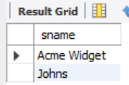

1. Find the pnames of parts supplied by Acme Widget Suppliers and by no one else.

select P.pname from PARTS P, CATALOG C, SUPPLIERS S where P.pid = C.pid and C.sid = S.sid and S.sname = 'Acme Widget' and not exists (select * from CATALOG C1, SUPPLIERS S1 where P.pid = C1.pid and C1.sid = S1.sid and S1.sname <> 'Acme Widget');

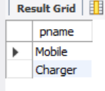

1. Find the sids of suppliers who charge more for some part than the average cost of that part (averaged over all the suppliers who supply that part).

select distinct C.sid from CATALOG C where C.cost > (select AVG(C1.cost) from CATALOG C1 where C1.pid = C.pid);

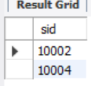

1. For each part, find the sname of the supplier who charges the most for that part

select P.pid , S.sname from PARTS P, SUPPLIERS S, CATALOG C where C.pid = P.pid and C.sid = S.sid and C.cost = (select MAX(C1.cost) from CATALOG C1 where C1.pid = P.pid);

